Souderton

Hometown Heroes Banners

The Souderton Hometown Heroes Banner Program is a living tribute created for the community to recognize and honor our Veterans who are serving or are veterans who have served our country in the United States Armed Forces.

To qualify, a Veteran, living or deceased, must have had a connection to Souderton (attended local schools, relative, friend, etc…) at some point in his or her life, also those honored on War Memorials and Veterans recommended by the local VFW and American Legion Posts.

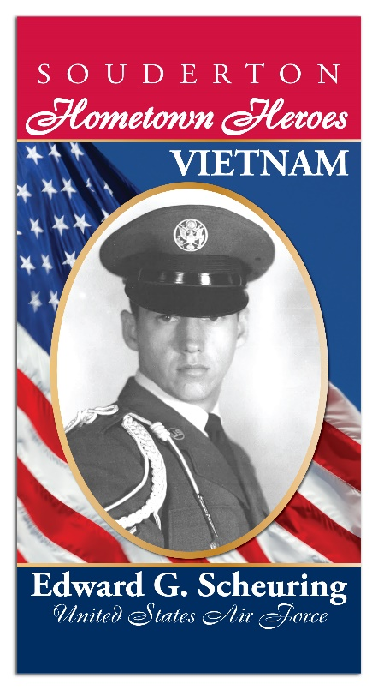

The Banner will be 24” x 48” heavy vinyl, printed the same on both sides, and will display the service person’s photograph, include their full name, branch of the Military and the era of service (WWI, WWII, Vietnam, etc.) Banners will be displayed from May through Veterans Day in November in observance of all Military Branch birthdays. Banners will be removed and stored until the same period in the following year at which time they will be redisplayed.

Each Banner requires the Hometown Hero Form to be filled out, a photograph of the Hero in uniform and a payment of $130.00 for each banner, payable to: Hometown Heroes

For further information please contact Anne Henning Scheuring, 225 South Line Street, Lansdale, PA. 19446 or at E-Mail address: [heroes@verizon.net](mailto:heroes@verizon.net) or call: (215) 855-1743

# Souderton Hometown Heroes

# Banner Program

Full Name of Person in Photo: ____________________________________________________________

Era of service ** (WWI, WWII, Vietnam, etc… ________________________________________________

Branch of Military: _____________________________________________________________________

Home town: __________________________________________________________________________

Is the Veteran? ALIVE __________ DECEASED ___________ KIA ___________ POW/MIA ____________

Name of person submitting photos: _______________________________________________________

Relationship to hometown hero: __________________________________________________________

Phone Number: ________________________________________________________________________

Address: _____________________________________________________________________________

E-Mail Address: ________________________________________________________________________

I hereby grant Hometown Heroes Committee permission to use the attached photo (which includes a likeness of me, my relative or person being sponsored) in the Hometown Heroes Banner Program without payment or other consideration.

_______________________________________________ __________________________________

Signature Date

_______________________________________________

Printed Name

**Era of Service - Official DOD Dates**

Global War on Terror: September 11, 2001 - Present

Desert Storm: January 17, 1991 - April 11, 1991

Persian Gulf: August 2, 1990 - August 31, 1991

Cold War: September 2, 1945 - December 26, 1991

Vietnam Era: February 28, 1961 - May 7, 1975

Korean Conflict Era: June 27, 1950 - January 31, 1955

WWII Era: December 7, 1941 - December 31, 1946

WWI Era: April 6, 1917 - November 11, 1918

Spanish - American War April 21, 1898 - July 4, 1902

War of 1812 1812 - 1815

Civil War 1861 - 1865

American Revolutionary War 1775 - 1783

**NOTE: Must Have - 1) Form filled out, 2) Photograph of hero in uniform, 3) Payment of $130.00 cash or check to: Hometown Heroes**

**Questions: Anne Henning Scheuring**

**Address: 225 S. Line St., Lansdale, PA 19446**

**Tel: (215) 855-1743 E-Mail:** [heroes@verizon.net](mailto:heroes@verizon.net)