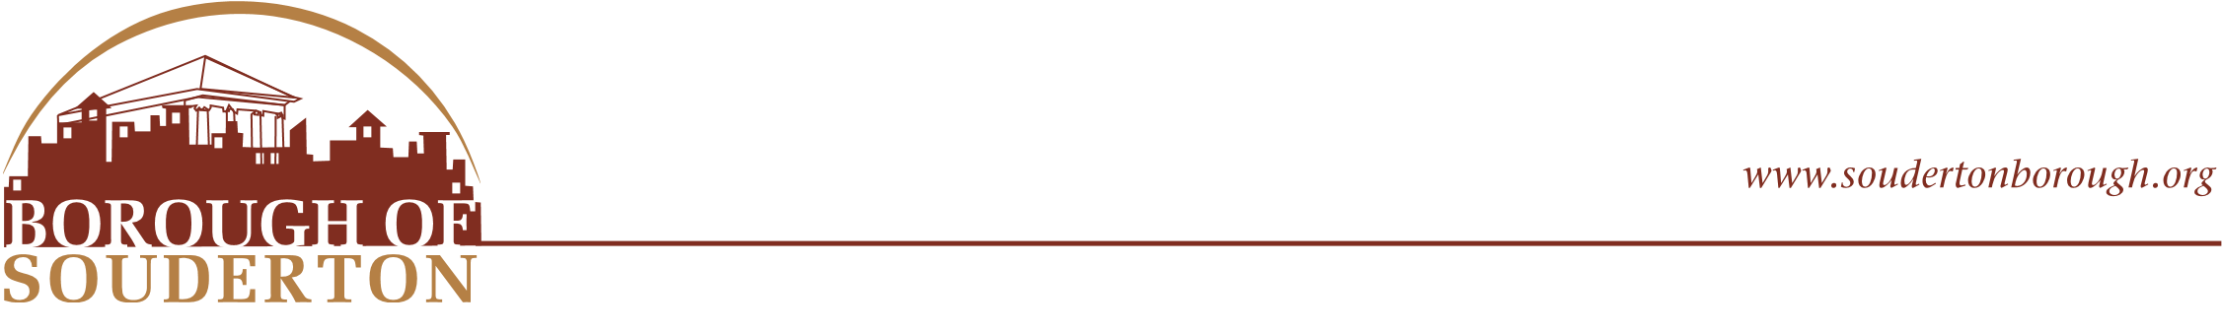
31 West Summit Street
Souderton, PA 18964
Phone: (215) 723-4371
Fax: (215) 723-5569
Borough Council Mayor
Julie Munden Daniel L. Yocum
Daryl Littlefield
Stephanie Costa
Donna M. Rogers
Matthew R. Sholly Borough Manager
Andy Richter Sara E. Jarrett-Eaton
Stephanie Cross
Daniel Bencsik

AGENDA
PLANNING COMMISSION
Wednesday, January 7, 2026 (7:00 pm)

- Call to Order

- Approval of Minutes- Wednesday, November 5, 2025

- Business

  - Reorganization
  - Zoning Ordinance Review and Updates

- Other Business and Reports

- Adjournment- Next Meeting Wednesday, February 4, 2026

*Public Attendance and Participation*
Meetings will be held in the rear Conference Room of the Souderton Municipal Building. Borough Residents, Property and Business Owners are always welcome to attend Planning Commission Meetings and will be provided with the opportunity to make public comment.

