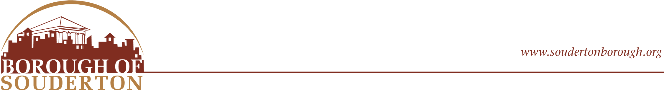
31 West Summit Street
Souderton, PA 18964
Phone: (215) 723-4371
Fax: (215) 723-5569

Public Works Laborer Position

Job Summary:

The Borough of Souderton is accepting applications for the position of Public Works Laborer. We are looking for a motivated individual to join our Public Works Department to assist with general maintenance of streets, parks, stormwater systems, borough buildings or facilities. This is hands – on position requiring physical labor in various weather conditions.

Key Responsibilities:

- As required, snow and ice control operations are performed on public roads. Operates snow removal equipment such as dump trucks, snow blowers, tractors, and shovels, and salting, equipment, during equipment winter months.
- Performs road maintenance such as patching roads, cleaning culverts, grading, paving, spreading stone, repairing potholes, replacing and patching curbs, grading road shoulders, collecting leaves, cutting and removing trees, removing or installing signs, and other tasks assigned.
- Assists in maintaining vehicles and equipment: basic repairs on trucks, rollers, sweepers, mowers, power tools, and other Borough equipment.
- Performs flagger and work zone traffic control duties as directed.
- Storm drains and sewer main upkeep. Responds to call outs for sewer issues, as required.
- Performs maintenance of stormwater management facilities including basins, channels, swales and naturalized areas.
- Locates and marks areas for safe digging and/or for PA One Call purposes.
- Inspects, repairs, and maintains playground, and park and recreation facilities.
- Performs routine building maintenance tasks and minor plumbing, carpentry, electrical and other tasks as assigned.
- Operate power driven machinery such as chain saws, pruning equipment, hedge trimmers, string trimmers or other power equipment.
- Performs lawn and garden maintenance activities to include mowing (riding and push mowers), weed whacking, raking, watering, weeding, fertilizing, tree trimming and removal, etc.
- Assists staff from other borough departments and/or divisions, as needed.
- Ability to work weekends when scheduled and respond to call outs as requested by the Director of Public Works.
- Operates dump trucks, tractors, excavation equipment, lawn mowers, snow removal equipment, power tools, hand tools, and other related equipment as directed.
- Behaves in a professional and courteous manner when interacting with the public and other employees.
- Adheres to all Borough and Departmental policies and procedures to deliver services in a safe, professional, and efficient manner.
- Utilizes all safety-related personal protective equipment to maintain a safe work environment.
- Executes the responsibilities of the position in a competent, timely, collaborative, and professional manner, in strict accordance with all applicable laws and reflects the Borough high standard of ethical behavior and commitment of service to its citizens.
- Performs any other duties as assigned.

Physical Requirements:

The physical requirements of the job include, but are not limited to, the following:
- Ability to sit, stand, and walk for extended periods of time.
- Ability to climb occasionally.
- Ability to squat, crawl, crouch, and kneel occasionally.
- Ability to bend or stoop frequently.
- Ability to speak and hear clearly; frequently communicate with co-workers, staff from other entities, and the public to exchange accurate information in these situations.
- Adequate near and distance vision, peripheral vision, depth perception and the ability to adjust focus.
- Ability to balance continuously.
- Manual dexterity (i.e., use of fingers, hands, and arms), including fine manipulation and the ability to grasp firmly.
- Ability to lift, move, push and/or carry up to 50 lbs. on a consistent basis and ability to lift to 150 lbs. with assistance.
- Ability to withstand exposure to weather frequently.
- Ability to routinely drive automotive equipment to other locations within and outside of the Borough.

Qualifications:

• High school diploma or equivalent. Prior Public Works experience preferred but not required.
• Ability to obtain and maintain a valid Pennsylvania Class-B Commercial Driver’s License within the first 12 months of employment; Current Commercial Class-B license, Class-A preferred.

Position Type:

Public Works Laborer – Starting Pay $24-$27/ hourly
Full-Time (Monday–Friday, 7:00 AM–3:30 PM)
On-call availability required for weekends, emergencies, and snow events.

Job Location:

Public Works Building, Municipal Building, and various sites within and outside of the Borough. Working environments may be inside or outside, on site or in various job locations throughout the borough. At times, it will require working in conditions exposed to extreme heat, or cold, noise, high winds, and bright or dark conditions.

Compensation and Benefits:

- Paid vacation, personal, sick days, and holidays
- Medical benefits, Dental, vision
- Deferred compensation (457b)
- Pension Plan - Short- & Long-Term Disability
- Life Insurance

Join our team and contribute to the vital work of municipal services, while enjoying a rewarding career with competitive benefits.

How to Apply: Interested candidates are invited to submit their resumes or applications to the Borough Office or to Sara Jarrett-Eaton Borough Manager, sjarrett@soudertonborough.org Accepted until February 18th.

The Borough of Souderton is an EOE.

